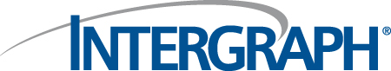
PinJig Naming Rules –
Structural Manufacturing

PinJig Naming Rules.doc
Status: Draft
Author: StructMfg-Team

SM3D Concept Design Document.
January 4 , 2012
© 2012 Intergraph Corporation. All rights reserved.
The content of this document is proprietary work of Intergraph Corporation, or relevant third parties, and is protected by copyright law and international treaty. Any use, duplication, distribution or disclosure of such, other than as specified herein, is unauthorized and in violation of applicable copyright law and international treaty. All rights in content or materials bearing copyright notice or other attribution of third party rights are reserved to the relevant third party. United States Government license rights are limited to those mandatory rights identified in DFARS 252.227-7015(b).
Intergraph may make improvements and/or changes in the products and/or the programs described in this publication at any time without notice.
Any content or materials supplied hereunder are provided "as is," without warranty of any kind, either expressed or implied, including, but not limited to, any implied warranties of merchantability, fitness for a particular purpose, or against infringement. In no event shall Intergraph be liable for any damages arising out of, or in connection with the downloading, viewing, use, duplication, distribution or disclosure of any content or material published by Intergraph, including but not limited to any direct, indirect, incidental, special, punitive or consequential damages, or loss or corruption of data.
Some jurisdictions do not allow the exclusions or limitations set forth above, so the above may not apply to you. The exclusions or limitations shall apply in all jurisdictions to the maximum extent allowed by law.

Intergraph Corporation
170 Graphics Drive
Madison, AL 35758
Phone: +1.256.730.2000
Toll Free USA: +1.800.345.4856
Fax: +256.730.2048

Contents
Introduction 2
References 2
Definitions 2
Bulkload 3
Rule Framework and Implementation 3

Revision # | Date Revised | Revised By | Description
0.1 | 04 -Jan- 2012 | Manasa Jaisetty | Initial Version.

Introduction
The purpose of this document is to describe the framework of PinJig naming rule.

References

Definitions

Bulkload
- The naming rules are avialble in “NamingRules” sheet of “StructMfgNamingRules.xls” workbook. User can modify the prog-id for “CPinJig” rule.
Location: “\ShipCatalogData\BulkLoad\DataFiles\StructManufacturing\StructMfgNamingRules.xls”

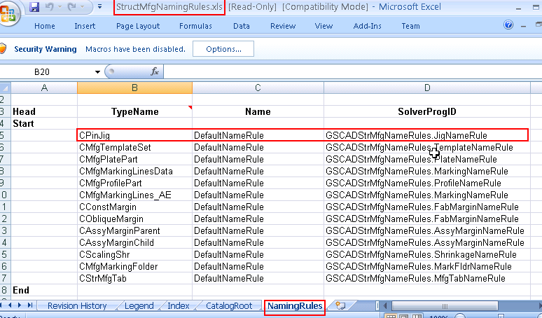

Rule Framework and Implementation

The PinJig naming rule is delivered at the below location:
- “\SharedContent\Src\StructManufacturing\Rules\PinJig\Naming”

The purpose of this rule is to specify the name for the PinJig object. The PinJig command associates the name rule and the name rule semantics to the object. This framework gives user flexibility to go for different naming rules. User needs to modify the solver ProgId in the namingrules sheet.

WORKFLOW:

- PinJig command gets the available naming rules for the PinJig object, creates the naming rules and associates the semantic relations
- The methods exposed in the rule are invoked by the naming rule semantics

The naming rule class(JigNameRule.cls) implements “IJNameRule” interface.
Following methods are exposed on IJNameRule interface:
1. ComputeName
Signature: Private Sub IJNameRule_ComputeName(ByVal oPinJigBeingNamed As Object, ByVal oPinJigParentsColl As IJElements, ByVal oActiveEntity As Object)
Input: PinJig object to be named, PinJig naming parent objects collection, Naming rules active entity on which the NamingParentsString is stored
Output: Computes a name for the object passed in.
Description: This method creates a name for the object passed in. The name is based on the parents name and object type. It is something like this: "Base Name" + "Object Name" + Index. "Base Name" is derived from the Naming Parents and the Index is unique for the "Base Name". It is assumed that all Naming Parents and the Object implement IJNamedItem.
- If the parent is a Plate then the name will be: "PJ_" + name of parent
- If the parent is an Assembly then the name will be: "AJ_" + name of parent + "-" + serial number. Serial number will be sequential and unique within each assembly.
- If the parent doesnot support “IJNamedItem”, the method would assign a default name

2. GetNamingParents
Signature: Private Function IJNameRule_GetNamingParents(ByVal oMfgJig As Object) As IJElements
Input: Pinjig object
Output: Naming parents that would influence the name of the Pinjig object
Description: All the Naming Parents that need to participate in the input object’s naming are added to the output collection. The parents added here are used in computing the name of the object in ComputeName() method of the same interface.
- The current implementation returns the parent plate part or the parent assembly.

